**NAMA : ABDURRAZZAQ ILHAM AZIZ**

**KELAS : A11.45O8**

**NIM : A11.2022.14301**

**TUGAS 7 DATA MINING**

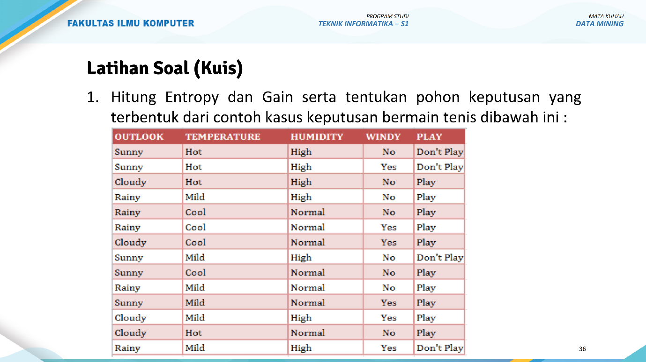1. **Menghitung Entropy:**

Total data = 14 kasus

Play = 9 kasus

Don't Play = 5 kasus

Entropy(S) = -P log₂(P) - N log₂(N)

= -(9/14)log₂(9/14) - (5/14)log₂(5/14)

= -(0.643 × -0.637) - (0.357 × -1.485)

= 0.408 + 0.532

= 0.940

**A. Outlook (Sunny, Cloudy, Rainy):**

Sunny (5 kasus): 2 Play, 3 Don't Play

Entropy(Sunny) = -(2/5)log₂(2/5) - (3/5)log₂(3/5) = 0.971

Cloudy (4 kasus): 4 Play, 0 Don't Play

Entropy(Cloudy) = 0 (karna semua bermain)

Rainy (5 kasus): 3 Play, 2 Don't Play

Entropy(Rainy) = -(3/5)log₂(3/5) - (2/5)log₂(2/5) = 0.971

Gain(Outlook) = Entropy(S) - Σ((|Sv|/|S|) × Entropy(Sv))

= 0.940 - (5/14 × 0.971 + 4/14 × 0 + 5/14 × 0.971)

= 0.940 - (0.347 + 0 + 0.347)

= 0.246

**B. Temperature (Hot, Mild, Cool):**

Entropy (Hot) = -(2/6)*log2(2/6) - (4/6)*log2(4/6) = 0.918

Entropy (Mild) = -(4/6)*log2(4/6) - (2/6)*log2(2/6) = 0.918

Entropy (Cool) = 0 (karna semua bermain)

Entropy Temperature = (6/14)*0.918 + (6/14)*0.918 + (2/14)*0 = 0.849

**C. Humidity (High, Normal):**

Entropy (High) = -(7/10)*log2(7/10) - (3/10)*log2(3/10) = 0.881

Entropy (Normal) = 0 (karna semua bermain)

Entropy Humidity = (10/14)*0.881 + (4/14)*0 = 0.629

**D. Windy (Yes, No):**

Entropy (True) = -(3/9)*log2(3/9) - (6/9)*log2(6/9) = 0.918

Entropy (False) = -(5/5)*log2(5/5) = 0

Entropy Windy = (9/14)*0.918 + (5/14)*0 = 0.605

**2. Menghitung Gain**

Gain(Outlook) = Entropy(Total) - Entropy(Outlook) = 0.940 - 0.694 = 0.246

Gain(Temperature) = Entropy(Total) - Entropy(Temperature) = 0.940 - 0.849 = 0.091

Gain(Humidity) = Entropy(Total) - Entropy(Humidity) = 0.940 - 0.629 = 0.311

Gain(Windy) = Entropy(Total) - Entropy(Windy) = 0.940 - 0.605 = 0.335

**3. Hasil Akar Pohon Keputusan**

Don’t Play

Play

False

True

Windy